Upgrading FC_MarkCode System of FC Laser Marking Barcode System

In spite of the introduction of new marking spec. The marking data were need to be constructed with respect to the Manufacturing Instruction (MI). This result the entire FC_MarkCode system needed to be upgraded in order to fulfill the requirement.

The present system was constructed based on the fixed criteria of marking concept which is “AywwL” where “A” is Frequency, “yww” represent weekcode and “L” represent the manufacturer plant. However, the recent update required a dynamic change of manufacturer plant label with respect to the MI. The system upgrade process is as the following.

- Create spec. file for marking process.
- Modified the present FC_MarkCode system’s Web Service.
- Modified the present FC_MarkCode system’s main core program in order to call the new reference service from the Web Service.

Create Spec. File for Marking Process

In order to make the system entirely dynamic, the Spec. database were designed as a text file format where the filename represented by the Spec. No. itself. Figure below shows the content of the spec. file.

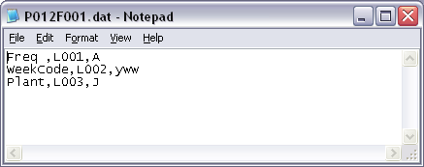

Text file has been chosen since it can be manipulated by any text editor as well as it is easy to handle. The End-User can modified the file or create a new file without needed to modify any software of the system.

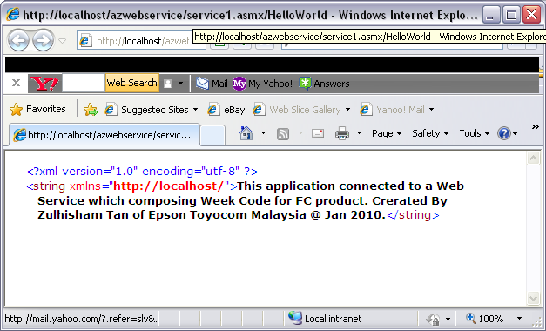
Web Service Modification

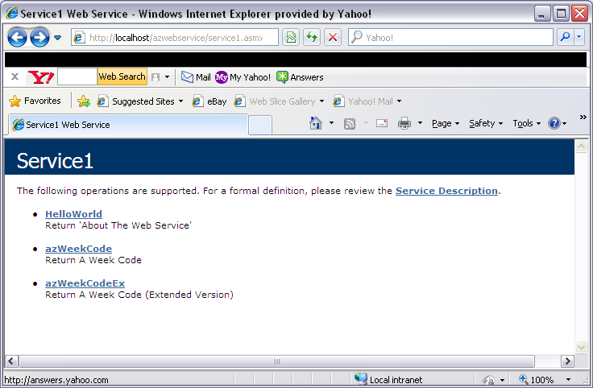

The system Web Service handles the business logic. The marking data is constructed by the service. Since the marking concept is changed, as a result this service is needed to be update accordingly.

Main Core Modification

As the main core logic make a call to the Web Service in order to obtain a marking data. This logic needed to be updated in spite of the service reference has been switch to a new service in the Web. The new version of calling method will attached the Spec. File to the Web Service so that the Marking Data was constructed based on the MI statement.

The Design

The construction was design as it is targeted to provide significant dynamic changes or software update which aim to minimize the interruption to the production daily schedule since the Spec. File can be edited at anytime. The Web Service can be deployed to the Web Server through FTP with almost zero interruption even though the machine is in run mode. Whereas, the main core logic is integrated with the latest .Net technologies - ‘ClickOnce’, where software is being deployed through the network.

In fact, the construction of the entire system is design in modular style which provides significant flexibility to engineer to maintain the system.

MI will continue deploy latest technologies in order to maximize system efficiency and effectiveness.

Zulhisham Tan - 21th Dec ‘2010

